**Assignment 2 : Hands on practice on the Linux Basic Commands**

1 ls : List commands to show the content of directory



2 ls –l : To get detailed list of the directory content

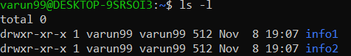

3 ls –a : To get the list Off all files/dir including hidden object.



4 pwd : Print Working directory



5 : mkdir directory_name To create a new directory.



6 touch :It is used to create file without content.



7 cat > : It is used to create a file with content. And can concatenate two or more file contents.

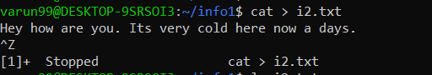

8 whoami : Prints the username of the active user.



9 cal :Cal command is used to display the calendar.

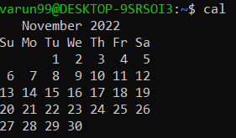

10 cd COMMAND : Cd command is used to change the directory.



11 cp : Used to copy files from one location to another. If the destination is an existing file, then the file is overwritten.

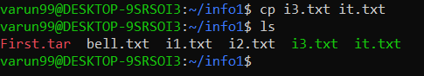

12 grep : grep command selects and print the lines from a file which matches a given string or pattern.



13 rm : This command delete the files

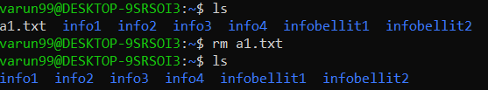

14 chmod : modifies the permissions of the file specified by file name to the permissions specified by permissions.

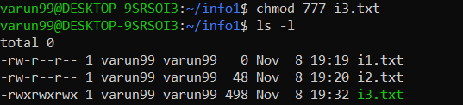

15 head : Used to display the first ten lines of a file



16 tail : Without any option it displays only the last 10 lines of the file specified.



17  Find : It can be used to find files and directories



18 awk : Awk is mostly used for pattern scanning and processing.



19  uname [-a] : Displays the operating system name as well as the system node name, operating system release, operating system version, hardware name, and processor type.



20 ps : To know the information about running processes in system

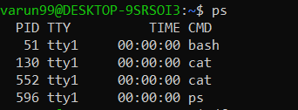

21 **df** : command that displays the amount of disk space available on the file system containing each file name argument.

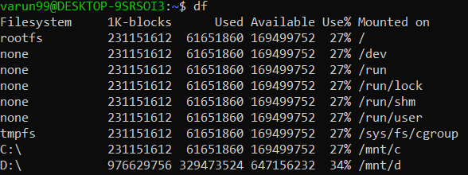

22 **du** command, short for disk usage, is used to estimate file space usage

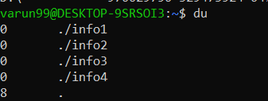

23 top : to view the information of running processes in detail

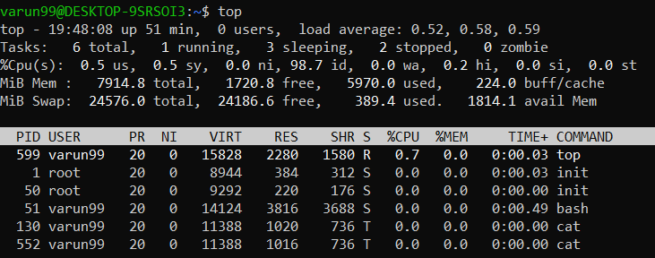

24 mv : To rename the file name

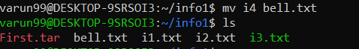

25 Tar : used for making TAR and compressed file

